Choice Activity
Vietnam War-Reflection

Watch the video “Looking Back” as four Vietnam Veterans reflect on their time in Vietnam and how it shaped the views they hold today. Answer the question that follows.

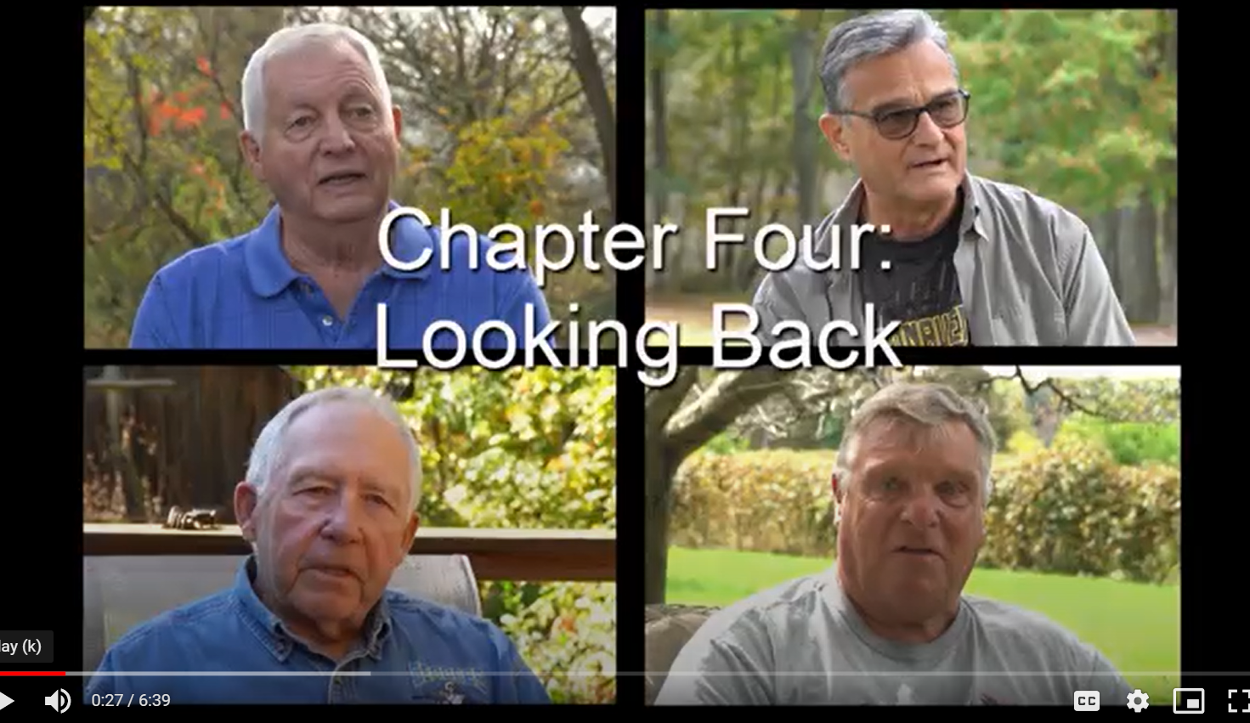

- Identify a similarity and/or difference in the way Vietnam shaped the ideas of these veterans. Give evidence to support your answer.

Now that you have analyzed the reflections of the veterans, read through the activities below. Choose ONE of the activities that will help you reflect on the Vietnam War. After completing the activity, answer the final question below.

Choice Activities
(choose one)

- Create a PROTEST POSTER
Posters must include:
- A clear message on Vietnam
- Must be school appropriate, but can be a reflection of the protests occurring at the time of the war
- ON THE BACK: Include the following information:
- Why were some people so against the war?
- Where did anti-war protests occur?
- How did anti-war protests impact American society?

- Write a letter to one of the local veterans in the video
Letters must include:
- Greeting and introduction
- What you saw in the videos, with some examples
- How the veteran’s experiences impacted you and the way you think about Vietnam
- Appropriate closing with appreciation

- Find a (school appropriate) Vietnam Era song that represents your view on the time period.
Include with the song:
- Identify THREE details from the song that represent your ideas on Vietnam; explain each with facts about Vietnam.
- Explain what this song tells us about people and society at the time it was written. Be specific with examples from the song and/or history.

- Find a picture of Vietnam that represents the time period for you.
Include with the picture:
- Identify a minimum of THREE objects, people or actions seen in the picture that shows something important about the time period. Explain each.
- Explain why this picture represents Vietnam to you.

FINAL QUESTION: What have you learned about Vietnam and how did these new ideas help
you understand Vietnam better? Explain with examples, facts and details
that help support your answer,

