Music from the Vietnam War Era
During the Vietnam War era, music helped people express their beliefs about America’s involvement. Some songs were patriotic, encouraging national pride and support for the troops serving overseas. Other songs were protest songs against what many viewed as an unnecessary war and a government who wouldn’t listen to its citizens.
Two songs that were popular during the Vietnam War era were “Okie From Muskogee” by Merle Haggard (1969) and “Blowin’ in the Wind” by Bob Dylan (1963). These songs represent opposing viewpoints of the Vietnam War. The following activity requires you to analyze both songs and answer the questions that follow.
Song #1: “Okie From Muskogee” by Merle Haggard (1969). Click here for the link to the song on YouTube: Okie From Muskogee
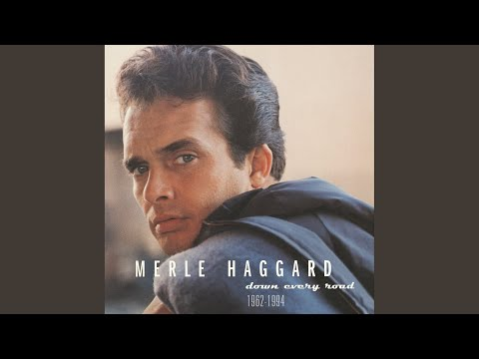
1) What stands out to you in this song?
2) How does this song make you feel?
Now read the lyrics to “Okie From Muskogee”
We don't smoke marijuana in Muskogee
We don't take our trips on LSD
We don't burn our draft cards down on Main Street
We like livin' right, and bein' free

We don't make a party out of lovin'
We like holdin' hands and pitchin' woo
We don't let our hair grow long and shaggy
Like the hippies out in San Francisco do

I'm proud to be an Okie from Muskogee,
A place where even squares can have a ball
We still wave Old Glory down at the courthouse,
And white lightnin's still the biggest thrill of all

Leather boots are still in style for manly footwear
Beads and Roman sandals won't be seen
Football's still the roughest thing on campus
And the kids here still respect the college dean

And I'm proud to be an Okie from Muskogee
A place where even squares can have a ball.
We still wave Old Glory down at the courthouse
And white lightnin's still the biggest thrill of all

3) In his song “Okie From Muskogee”, does Merle Haggard encourage Americans to support the war in Vietnam or protest US involvement? Cite evidence from the lyrics to support your answer.

Song #2: “Blowin’ in the Wind” by Bob Dylan (1963). Click here for the link to the song on YouTube: Blowin in the Wind
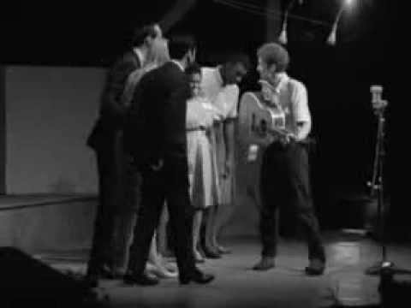
4) What stands out to you in this song?
5) How does this song make you feel?
Now read the lyrics to “Blowin’ in the Wind”:
How many roads must a man walk down
Before you call him a man?
Yes, n how many seas must a white dove sail
Before she sleeps in the sand?
Yes, n how many times must the cannon balls fly
Before they're forever banned?
The answer, my friend, is blowin' in the wind,
The answer is blowin' in the wind.
How many years can a mountain exist
Before its washed to the sea?
Yes, n how many years can some people exist
Before they're allowed to be free?
Yes, n how many times can a man turn his head,
Pretending he just doesn't see?
The answer, my friend, is blowin' in the wind,
The answer is blowin' in the wind.
How many times must a man look up
Before he can see the sky?
Yes, n how many ears must one man have
Before he can hear people cry?
Yes, n how many deaths will it take till he knows
That too many people have died?
The answer, my friend, is blowin' in the wind,
The answer is blowin' in the wind.

6) In his song “Blowin’ in the Wind”, does Bob Dylan encourage Americans to support the war in Vietnam or protest US involvement? Cite evidence from the lyrics to support your answer.

7) Which song do you prefer? Why?

